Create a React App named “bloggerapp” in with 3 components.

1. Book Details
2. Blog Details
3. Course Details

Implement this with as many ways possible of Conditional Rendering.

BookDetails.js

import React from 'react';

function BookDetails(props){

    return(

        <ul>

            {props.books.map((book) => (

                <div key={book.id}>

                    <h3>{book.bname}</h3>

                    <h4>{book.price}</h4>

                </div>

            ))}

        </ul>

    );

}

export default BookDetails;

BlogDetails.js

import React from 'react';

function BlogDetails(){

    return(

        <div>

            <h2>React Learning</h2>

            <h4>Stephen Biz</h4>

            <p>Welcome to learning React!</p>

            <h2>Installation</h2>

            <h4>Schwezdenier</h4>

            <p>You can install React from npm.</p>

        </div>

    );

}

export default BlogDetails;

CourseDetails.js

import React from 'react';

function CourseDetails(){

    return(

        <div>

            <h2>Angular</h2>

            <p>4/5/2021</p>

            <h2>React</h2>

            <p>6/3/20201</p>

        </div>

    );

}

export default CourseDetails;

App.js

import React, {useState} from 'react';

import BookDetails from './BookDetails';

import BlogDetails from './BlogDetails';

import CourseDetails from './CourseDetails';

import './App.css';

function App(){

  const[ active, setActive] = useState('books');

  const books=[{id:101,bname: 'Master React',price:670},

    {id:102,bname:'Deep Dive into Angular 11',price:800},

    {id:103,bname:'Mongo Essentials',price:450}

  ];

 const showBooks = true;

  const showBlogs = true;

  const showCourses = true;

  return (

    <div className="container">

      {showCourses && (

        <div className="mystyle1">

          <h1>Course Details</h1>

          <h2>Angular</h2>

          <p>4/5/2021</p>

          <h2>React</h2>

          <p>6/3/20201</p>

        </div>

      )}

      {showBooks && (

        <div className="st2">

          <h1>Book Details</h1>

          <ul>

            {books.map((book) => (

              <div key={book.id}>

                <h3>{book.bname}</h3>

                <h4>{book.price}</h4>

              </div>

            ))}

          </ul>

        </div>

      )}

      {showBlogs && (

        <div className="v1">

          <h1>Blog Details</h1>

          <h2>React Learning</h2>

          <h4>Stephen Biz</h4>

          <p>Welcome to learning React!</p>

          <h2>Installation</h2>

          <h4>Schwezdenier</h4>

          <p>You can install React from npm.</p>

        </div>

      )}

    </div>

  );

}

export default App;

Execution of the code:

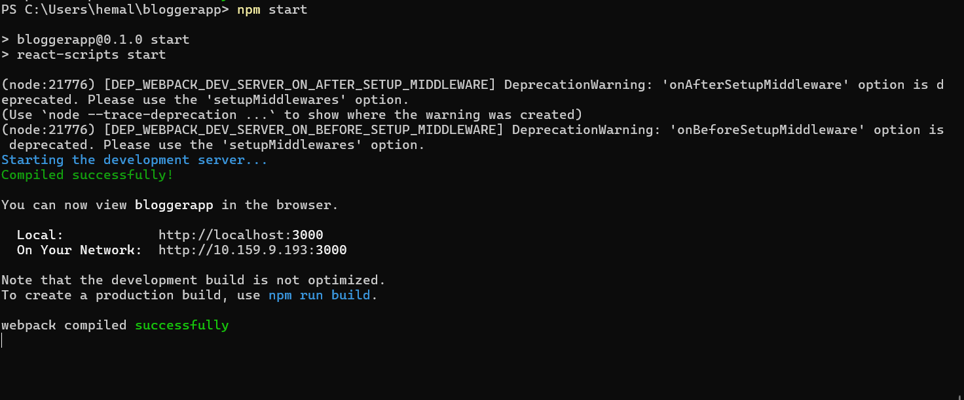

Output:

